Ntune Entertainment Group
Services
Magazine Promotion
Hip Hop Weekly
Option 1
Feature in Hip Hop Weekly Magazine
(Independent Artist Spotlight Section)
550$
Option 2
Feature in Hip Hop Weekly Magazine/Video Posted on HipHopWeekly.com
(Independent Artist Spotlight Section)
650$
Option 3
Feature in Hip Hop Weekly Magazine/Video Posted on HipHopWeekly.com/ Social Media via Hip Hop Weekly Staff
(Independent Artist Spotlight Section)
750$
ALL PACKAGES INCLUDE POST TO OUR 5 BLOGS & SOCIAL MEDIA SHARES
Popular Blog Promotion
HHSince1987
Option 1
Blog Post on HHSince1987
200$
Option 2
Blog Post on HHSince1987/Instagram Photo
300$
Option 3
Blog Post on HHSince1987/Instagram Video
350$
ALL PACKAGES INCLUDE POST TO OUR 5 BLOGS & SOCIAL MEDIA SHARES
Blog Post & Promotion
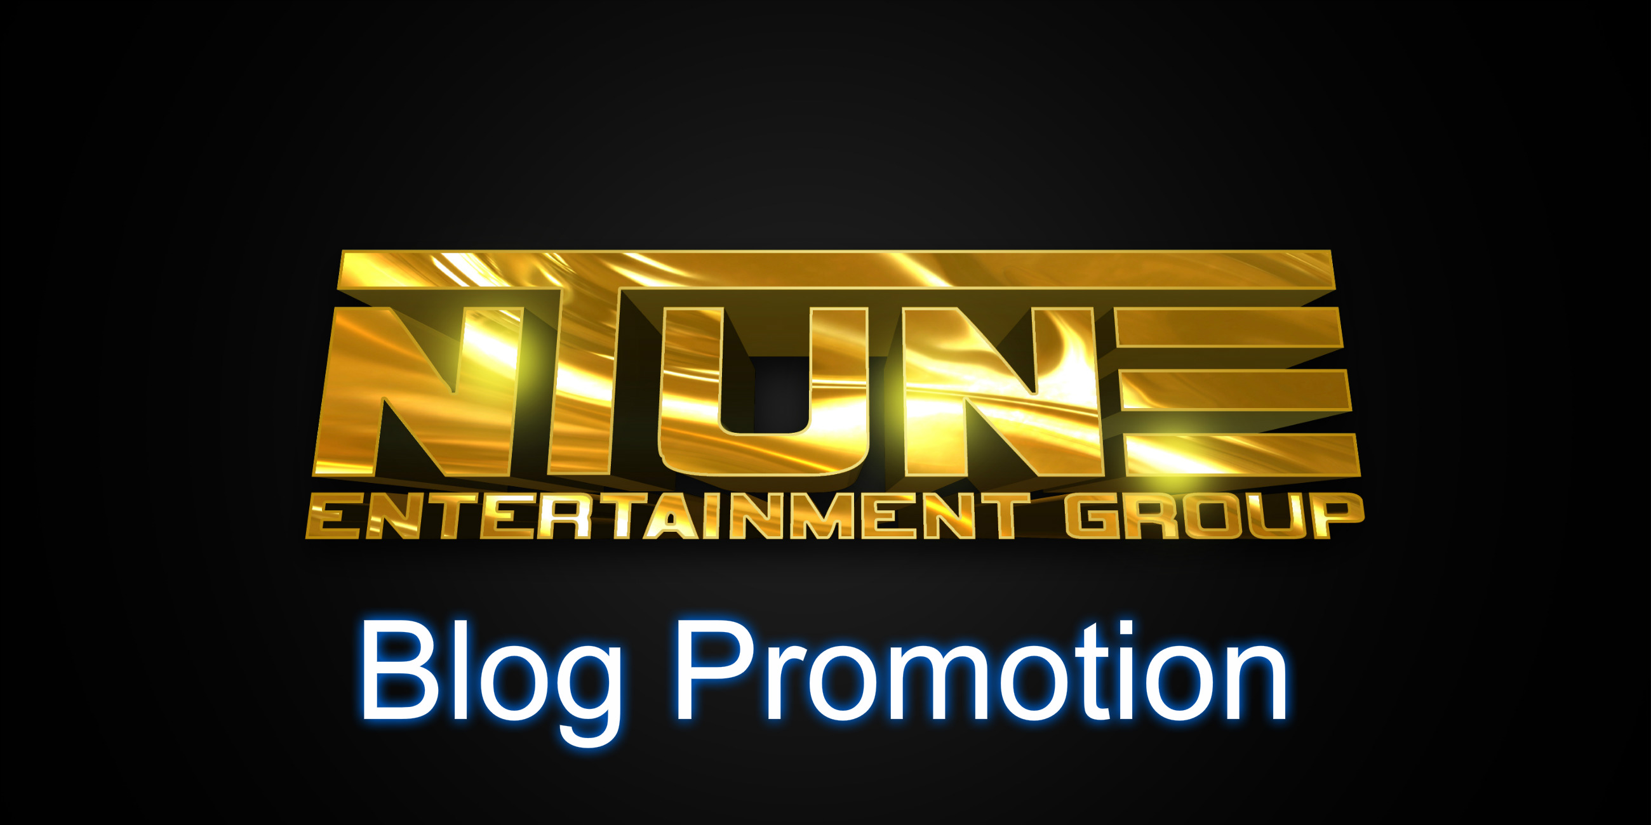
(Includes social media posts to Facebook & twitter)
Starter Package
Post to 2 Blogs of mixtape, single, video or product
5$
Intermediate Package 5 Blogs
20$
Post to 20 blogs of Mixtape, Single, Video or Product
Platinum Package
50$
Post to 20 Blogs of Mixtape, Single, Video or Product
Mixtape slots/Hosting & Promotion
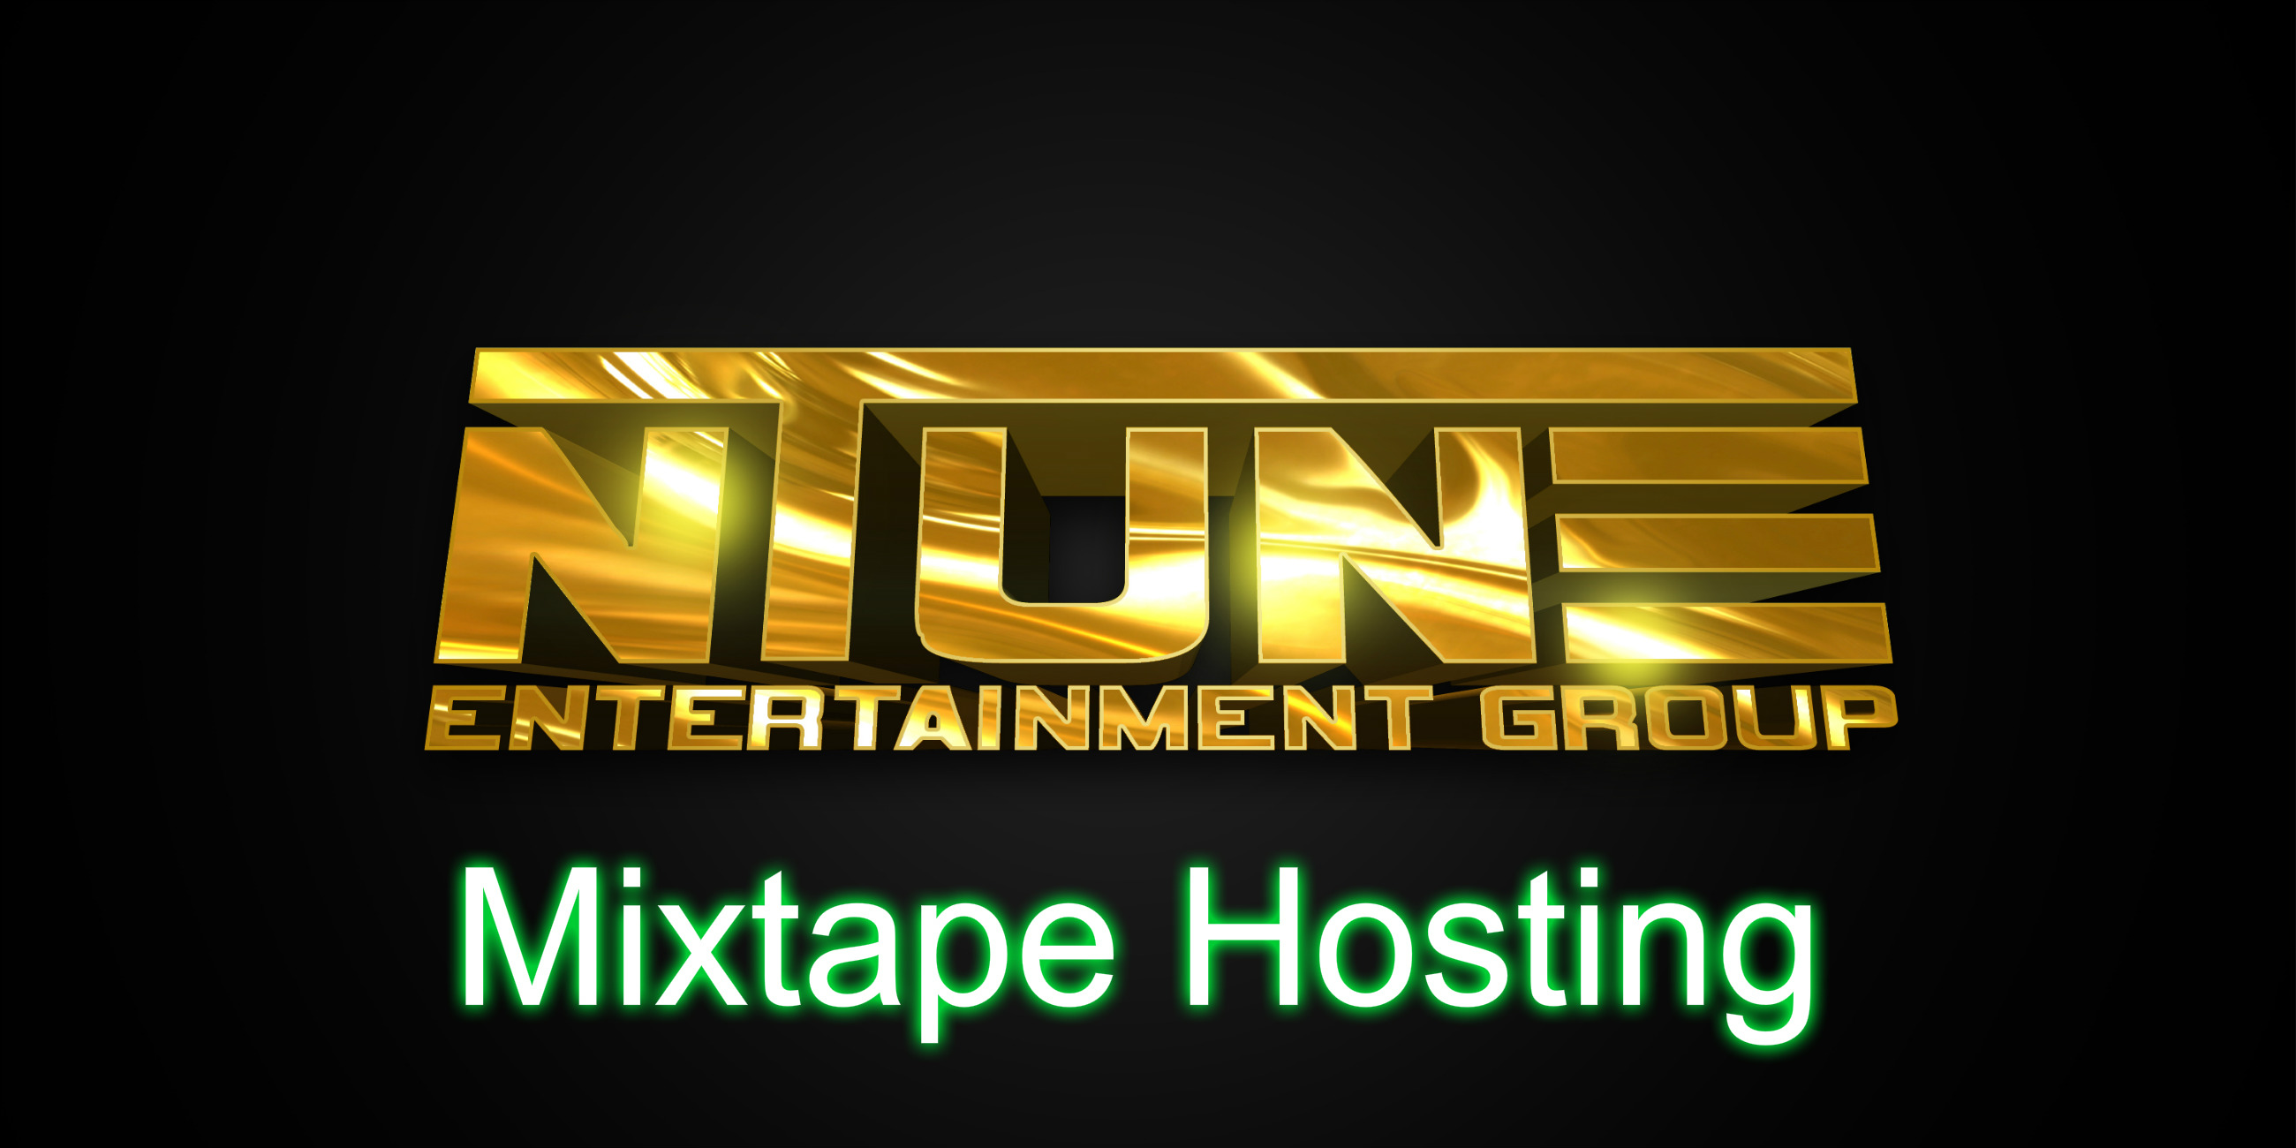
Social Media Campaign
(Twitter & Facebook)
The Rush Blog Interviews
50$
(Posted to 5 Blogs)
Social Media Campaign
(Twitter & Facebook)
Mixtape Hosting Packages
Starter Hosting
125$
(Includes Graphics Front Cover Only Back cover additional 25$ )
Mixtape Posted to Spinrilla /Coast Coast/Nerve Djs/Audio Mack, Datpiff and 5 Blogs
Social Media Campaign 2 Days
(Twitter & Facebook)

Mid Hosting
250$
(Includes Graphics Front & Back Cover)
Mixtape Posted to Spinrilla /Coast Coast/Nerve Djs/Audio Mack, Datpiff and 10 Blogs
Social Media Campaign 1 Week
(Twitter &Facebook)
Boss Hosting
375$
(Includes Graphics Front & Back Cover)
Mixtape Posted to Spinrilla /Coast Coast/Nerve Djs/Audio Mack, Datpiff and 20 Blogs
Social Media Campaign 1 Week
(Twitter& Facebook)
Banner Ad
(Posted on 5 Blogs Of Mixtape for 2 Weeks)
10 Spins on Coast 2 Coast Radio
(Single of your choice)
Slot Packages
1 slot 25$
2 slots 40$
3 slots 50$
Tapes are Posted on Spinrilla /Coast Coast/Nerve Djs/Audio Mack, Datpiff and 5 Blogs
Single/Mixtape Reviews
50 $
(Posted to 5 Blogs)
Social Media Campaign
(Twitter & Facebook)

Graphics
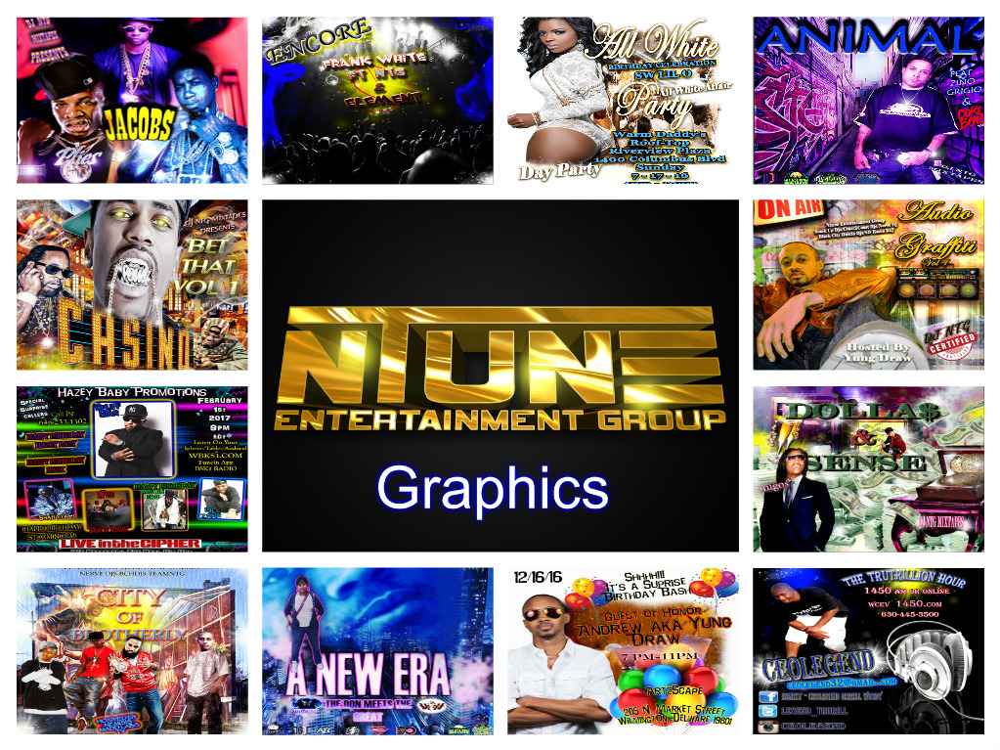
Mixtape/single covers 50$
Flyers 35$

NEED OTHER SERVICES UNLISTED???
Contact
theceo@ntuneentgrp.com
Packages for all budgets
www.ntuneentgrp.com
FYI : ONCE SERVICES ARE COMPLETED & ACCEPTED BY CLIENT ALL ADDITIONAL CHANGES/UPDATES WILL HAVE 25$ FEE
