Ntune Entertainment Group
Services
Magazine Promotion
Hip Hop Weekly
Option 1
Feature in Hip Hop Weekly Magazine
(Independent Artist Spotlight Section)
450$
Option 2
Feature in Hip Hop Weekly Magazine/Video Posted on HipHopWeekly.com
(Independent Artist Spotlight Section)
500$
Option 3
Feature in Hip Hop Weekly Magazine/Video Posted on HipHopWeekly.com/ Social Media via Hip Hop Weekly Staff
(Independent Artist Spotlight Section)
600$
ALL PACKAGES INCLUDE POST TO OUR 5 BLOGS & SOCIAL MEDIA SHARES
Popular Blog Promotion
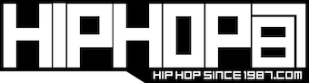
HHSince1987
Option 1
Blog Post on HHSince1987
100$
Option 2
Blog Post on HHSince1987/Instagram Photo
175$
Option 3
Blog Post on HHSince1987/Instagram Video
225$
ALL PACKAGES INCLUDE POST TO OUR 5 BLOGS & SOCIAL MEDIA SHARES
Blog Post & Promotion
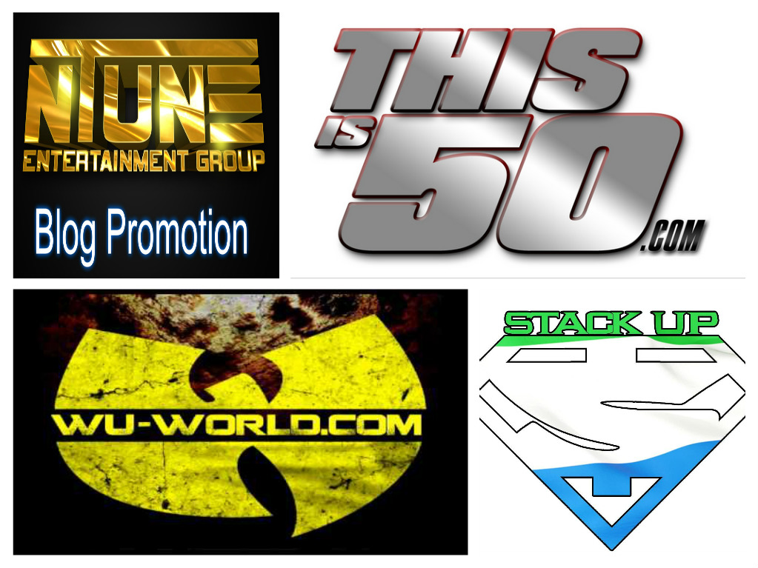
(Includes social media posts to
facebook, twitter and google-plus)
Starter Package
Post to 2 Blogs of mixtape, single, video or product
5$
Intermediate Package 5 Blogs
20$
Post to 20 blogs of Mixtape, Single, Video or Product
Platinum Package
50$
Post to 20 Blogs of Mixtape, Single, Video or Product
Boss Package
100$
Live Link Banner of Mixtape, Video, Single or Product for 2 weeks
Banner ad also placed on 2 additional websites for 2 weeks
Mixtape slots/Hosting & Promotion
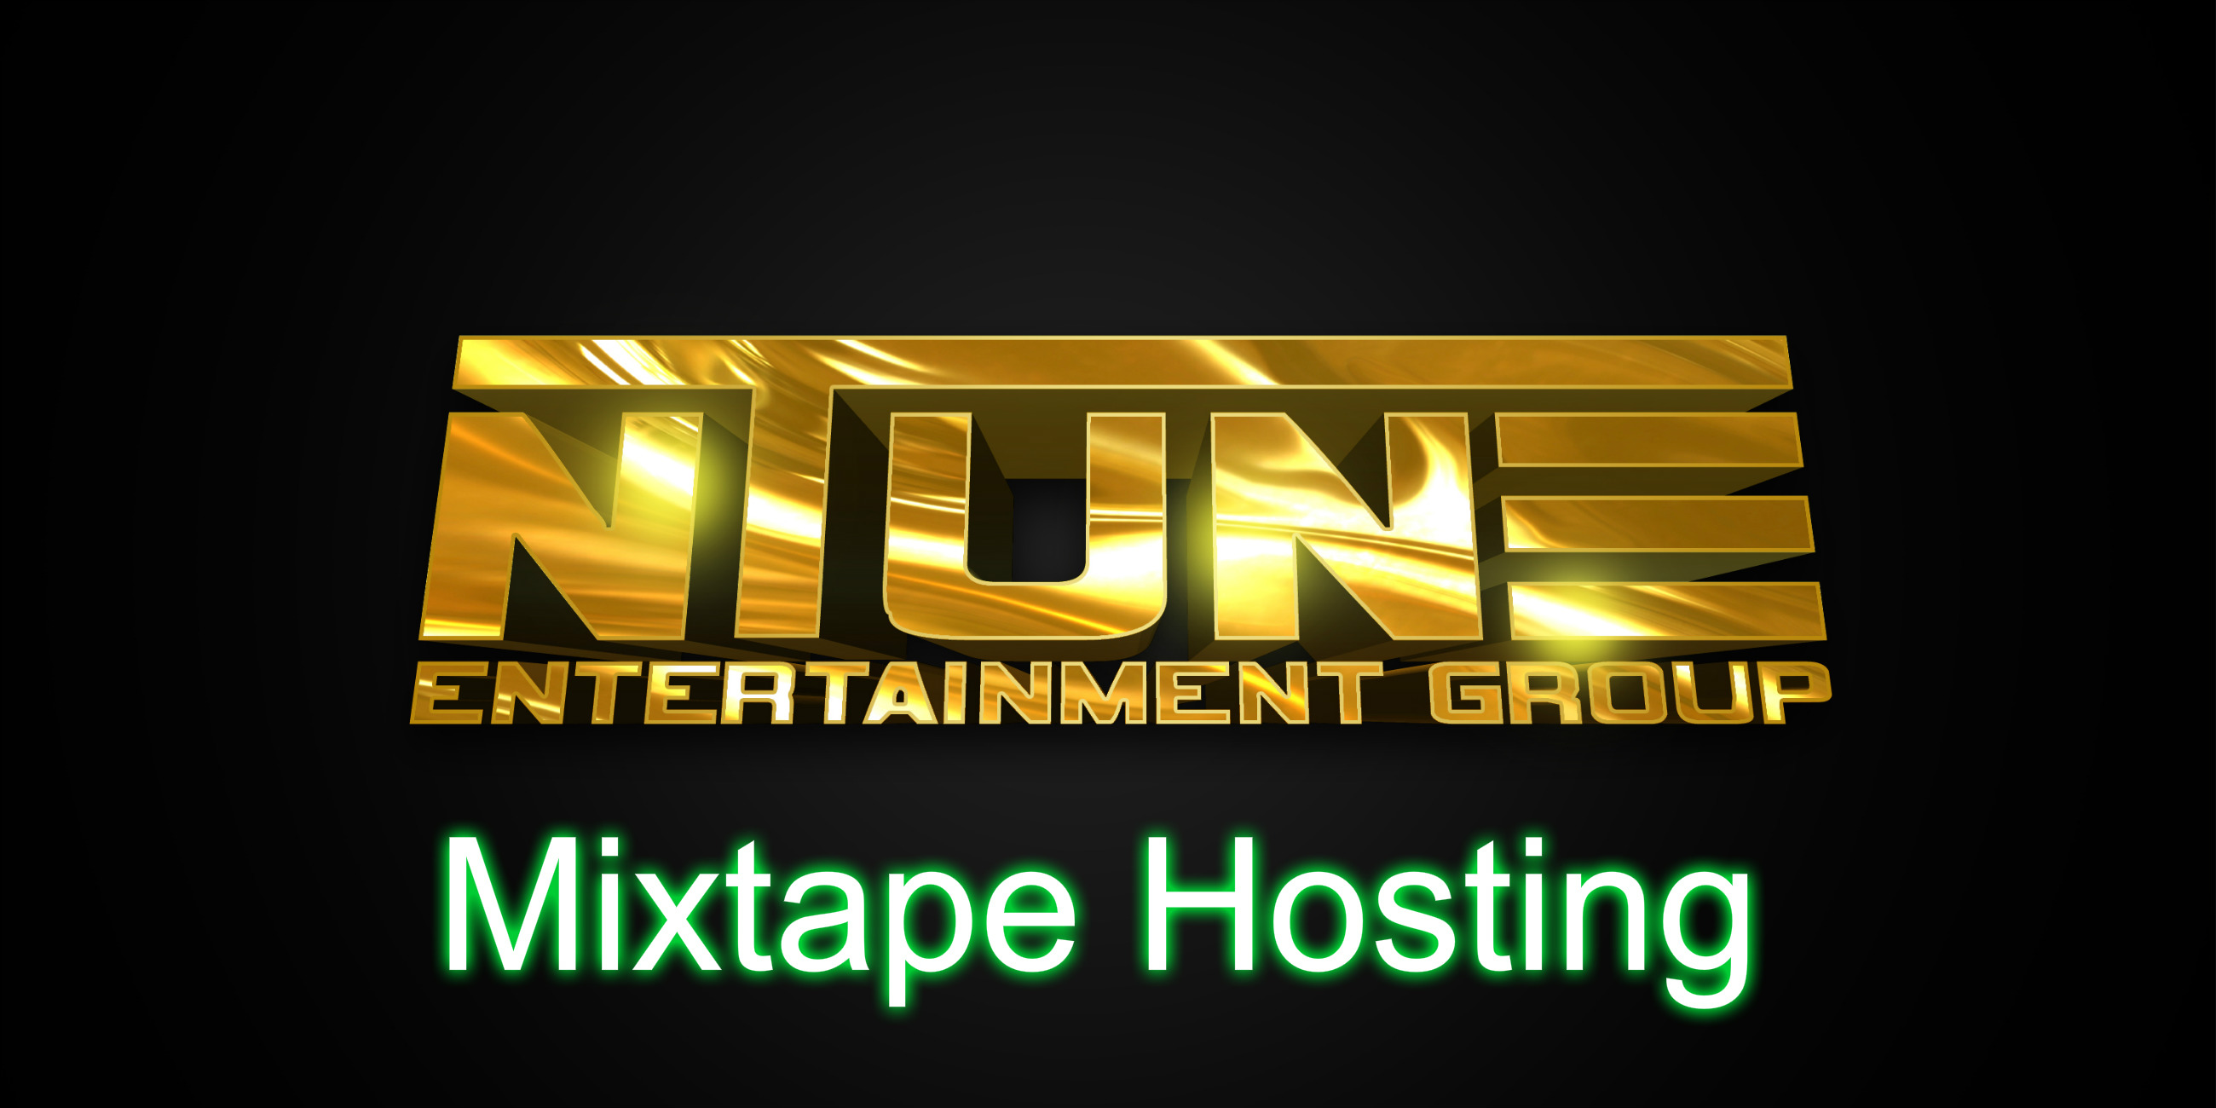
Social Media Campaign
(Twitter, Facebook, Google Plus)
The Rush Blog Interviews
25$
(Posted to 5 Blogs)
Social Media Campaign
(Twitter, Facebook, Google Plus)
Mixtape Hosting Packages
Starter Hosting
75$
(Includes Graphics Front Cover Only Back cover additional 25 )
Mixtape Posted to Spinrilla ,Stack Up Djs/Coast Coast/Nerve Djs/Audio Mack, Datpiff and 5 Blogs
Social Media Campaign 2 Days
(Twitter, Facebook, Google Plus)

Mid Hosting
150 $
(Includes Graphics Front & Back Cover)
Mixtape Posted to Spinrilla ,Stack Up Djs/Coast Coast/Nerve Djs/Audio Mack, Datpiff and 10 Blogs
Social Media Campaign 1 Week
(Twitter, Facebook, Google Plus)
Boss Hosting
300$
(Includes Graphics Front & Back Cover)
Mixtape Posted to Spinrilla ,Stack Up Djs/Coast Coast/Nerve Djs/Audio Mack, Datpiff and 20 Blogs
Social Media Campaign 1 Week
(Twitter, Facebook, Google Plus)
Banner Ad
(Posted on 5 Blogs Of Mixtape for 2 Weeks)
10 Spins on Coast 2 Coast Radio
(Single of your choice)
Slot Packages
1 slot 10$
2 slots 15$
3 slots 25$
4 slots 35$
(2 added to each tape)
Tapes are Posted on Spinrilla ,Stack Up Djs/Coast Coast/Nerve Djs/Audio Mack, Datpiff and 5 Blogs
Single/Mixtape Reviews
25 $
(Posted to 5 Blogs)
Social Media Campaign
(Twitter, Facebook, Google Plus)

Graphics
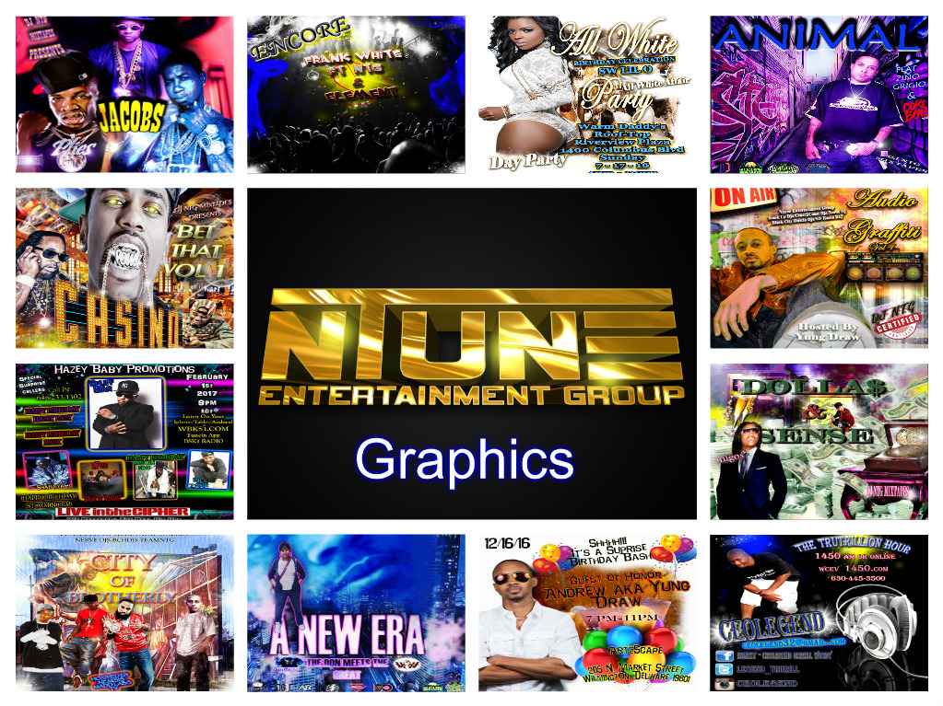
Mixtape/single covers 50$
Flyers 35$

NEED OTHER SERVICES UNLISTED???
Contact
theceo@ntuneentgrp.com
Packages for all budgets
www.ntuneentgrp.com

